County of Northamptonshire
INCLUDEPICTURE "cid:image002.jpg@01D740D7.A651BD40" \* MERGEFORMATINET 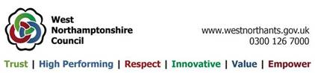
Yardley Gobion Parish Council

Yardley Gobion Parish Council

Notice is hereby given of the ANNUAL ASSEMBLY of Yardley Gobion Parish, to be held on Tuesday 2nd May 2023, at 7.15pm in the Village Hall, at which members of the public have the opportunity to meet and raise questions with Local Councillors.

Chairman L Stephenson 18/4/23

AGENDA

- Apologies for absence.

- Chairman’s Report.

- Accounts for 2022/23

- Report from Police.

- Report from Ward Councillor.

- Report from Yardley Gobion C of E Primary School.

- Report from Neighbourhood Watch.

- Other Parish Reports.

- Any other items of Parish business.

